This is a example out of the book:
Poker math that matters simplifying the secrets of no-limit holdem
Autor: Owen Gaines

I have documented this example so that it is easier to understand.

You can find the example on page: 86

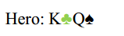

Villain Range: AQ+, TT

Our opponent bets pot. Which is better, calling or folding?
In order to decide, we begin with our pot odds.

He bets pot, so in order to call we know we need to be good at least 33% of the time.

We beat AK, but we lose to AQ and TT. We can look at the probability distribution of these hands to know how often we’re going to win. Let’s break it down.

We'll start by analyzing the hands that beat us. How many
combinations of AQ and TT are there? We have a Q, and there’s
one on the board. So there are only two Qs and four As to make
AQ.

Lets use this simple graphic to get the things more clear.
(Ok, there is no Q in the graphic because I have no AQ graphic.^^ So lets say the K in the graphic is a Q. :-D )

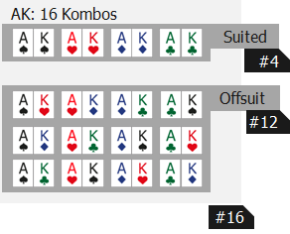

There is one Q♦ on the board and hero holds also a Q♠. So lets remove all Q♦ (this Queens lie on the board ) and Q♠ (this is one of heros hole cards) from the graphic.

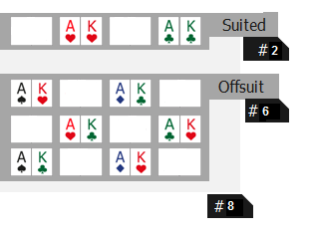

As you can see in the graphic there are only 8 combinations left for AQ.

How many combinations are left for the T?
With TT you have 6 different combinations. But one T is already on the board. So we have only 3 combinations for T left. How is that possible? Just look in the graphic. (Yes, the graphic shows QQ but I have no graphic with TT. But it makes no different in the combinations between TT and QQ … )

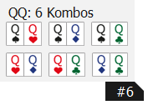

The T on the board is T♥ so lets remove T♥ out of the graphic.

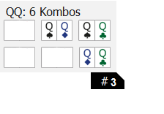
As you can see there are only 3 combinations left.
So, we have 8 combinations for AQ and 3 combinations for TT.

8+3 = 11 combinations

And that means now: There are 11 combinations that beat us.

Which hands can we beat?

Now, let’s look at the hands we beat. How many combinations
of AK are there? We have a K, so there are three Kings and four
Aces in the card deck.

Hero holds K♣ lets remove all K♣ out of the graphic.
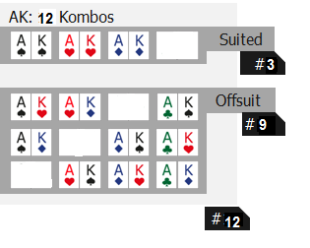

As you can see we have 12 combinations left. That means that we can beat Villains range with 12 combinations.

There are 11 combinations that beat us, and 12 combinations we beat. This is a total of 23 combinations.
We can divide the combinations of AK by the total combinations to see how often we will win if we call.

12/23 = 0.52
We will win about 52% of the time.

And remember Villains Pot bet he give us 2:1 odds.

Calculate 2:1 in %

1 / (2+1)*100 = 33%

We only need to be good 33% to break even, so we have an easy call.

