Vs. 1 Limper
Most of the times limper on the micro stakes are just big fish. So I guess the position of the limper is not that important. If the fish has a hand that he likes then he will play it regardless of his position on the table.

Hero SB open raise range:

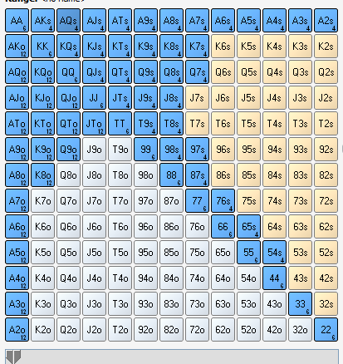

22+,A2s+,K7s+,Q7s+,J8s+,T8s+,97s+,87s,76s,65s,54s,A2o+,K8o+,Q9o+,JTo

Hero SB iso-raise range:
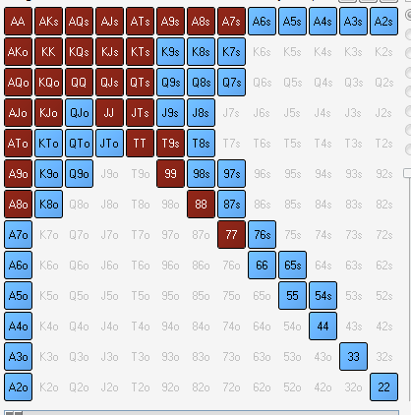

A8o+, A7s+, KJo+, KTs+, QTs+, T9s+, 77+

Hero BTN open raise range:
22+,A2s+,K2s+,Q2s+,J6s+,T8s+,97s+,86s+,75s+,65s,54s,A2o+,K6o+,Q8o+,J8o+,T9o,98o

